AN EMPLOYEE REQUESTS INSTALLATION OF LICENSED SOFTWARE
THROUGH THE SERVICE CATALOG
Complete Project Documentation
ServiceNow – Service Portal, Service Catalog, Flow Designer, Approvals, ACLs and Notifications
Project | An Employee Requests Installation of Licensed Software through the Service Catalog
Platform | ServiceNow
Primary Interface | Service Portal
Workflow | Catalog → Validation → License Check → Approval → Installation Task → Status → Notification


The project focuses on developing an automated Licensed Software Installation Request Management system using ServiceNow. The solution provides employees with a simple and structured way to request installation of approved licensed software through the Service Catalog.
The main purpose is to capture software requirements accurately, validate the request, check license availability, obtain the required approval, create a fulfillment task for the IT/software team, and keep the requester informed through status updates and notifications.
The system uses Service Catalog, Catalog Item, Catalog Variables, Catalog UI Policies, Catalog Client Scripts, Flow Designer, Approval Requests, fulfillment tasks, Access Controls, Notifications, and reference data to manage the software request lifecycle.

Project Workflow
The implemented process follows this sequence:
- Employee opens the Licensed Software Request catalog item through the Service Portal.
- Employee enters software name, version, business justification, device details, installation location, and other required information.
- Catalog validation checks mandatory fields and applies dynamic form behavior.
- Employee submits the request using Order Now.
- ServiceNow creates the Request (REQ) and Requested Item (RITM) records.
- Flow Designer validates the request and checks license availability.
- The request is routed through the configured approval process.
- Once approved, the workflow creates a Software Installation Task for the IT/software fulfillment team.
- Notifications are generated at important stages.
- The fulfillment team processes the task and updates its status.
- The completed request can be tracked through ServiceNow.

Project Phases
The project was implemented through the following phases:

1. Requirement Analysis & Planning – Identifying the need for employees to request licensed software through the Service Catalog and defining the required software, user, device, business justification, approval, and installation details.

2. Service Catalog & Form Configuration – Creating the Licensed Software Request Catalog Item, configuring catalog variables and variable sets, and setting mandatory fields and appropriate software choices.

3. UI/UX Development & Customization – Designing the Service Portal request form and configuring Catalog UI Policies and Catalog Client Scripts to control field visibility, mandatory fields, and dynamic form behavior.

4. Workflow Automation & Approval – Using Flow Designer to automate request validation, license availability checking, approval processing, Software Installation Task creation, status updates, and notifications.

5. Testing & Security – Configuring Access Control Lists (ACLs), validating user permissions, performing functional testing, and conducting User Acceptance Testing (UAT) to ensure the complete software request workflow works correctly.

6. Deployment, Documentation & Final Presentation – Preparing the solution for deployment, validating the final configuration, documenting the ServiceNow implementation and testing results, demonstrating the complete licensed software request workflow, and identifying future enhancements.

Final Outcome
The completed project provides a structured and automated process for employees to request installation of licensed software through the ServiceNow Service Catalog.
The main outcome is an end-to-end workflow in which the employee submits the software request, provides the required details, and the system validates the information and checks license availability. The request is then routed for approval, and once approved, a Software Installation Task is automatically created and assigned to the IT/software fulfillment team.
The system also provides request status tracking and notifications throughout the process, giving employees visibility into the progress of their software installation request.

2. Phase 1 – Requirement Analysis & Planning
Step 1: Understand the Project Requirement
The main requirement is to provide employees with a centralized ServiceNow Service Catalog item through which they can request installation of licensed software.
The system should:
- Allow employees to select the required licensed software.
- Capture necessary details such as Requested For, Software Name, Software Version, Device, Installation Details, and Business Justification.
- Validate the information entered by the employee.
- Check whether the required software license is available.
- Send the request for the required approval.
- Automatically create an installation task for the IT/software team after approval.
- Allow the employee to track the request status.
- Send notifications at important stages of the request.
Step 2: Identify Stakeholders
The major stakeholders involved in the process are:
- Employee / Requester – submits the licensed software installation request.
- Manager / Approver – reviews and approves or rejects the request.
- IT / Software Team – validates the license and performs the software installation.
- ServiceNow Administrator – configures the Service Catalog, workflow, security, and notifications.
Step 3: Define ServiceNow Components
The following ServiceNow components are planned for the project:
- Service Catalog
- Licensed Software Request Catalog Item
- Catalog Variables
- Variable Sets
- Catalog UI Policies
- Catalog Client Scripts
- Flow Designer
- Approval Request
- Software Installation Task
- Notifications
- Access Control Lists (ACLs)
- Request (REQ) and Requested Item (RITM)

Step 4: Define the Request Process
The planned request process is:
Employee → Service Portal → Licensed Software Catalog Item → Enter Details → Submit Request → License Validation → Approval → Installation Task → Software Installation → Status Update → Notification
Step 5: Define Functional Requirements
The system should provide the following functionality:
- Employee can access the Service Catalog.
- Employee can open the Licensed Software Request item.
- Employee can select the required software.
- Employee can provide the required installation details. 7
- Mandatory fields must be validated before submission.
- A request and requested item should be generated after submission. Edx License availability should be checked.
- The request should be routed for approval.
- An installation task should be created after approval.
- The IT team should be able to update the task status.
- The requester should receive status notifications.
- The complete request should remain traceable in ServiceNow.
Step 6: Project Planning
The overall project is planned in the following sequence:
Requirement Analysis & Planning → Service Catalog & Form Configuration → UI/UX Customization → Workflow Automation & Approval → Testing & Security → Deployment, Documentation & Final Presentation

3. Phase 2 – Service Catalog & Form Configuration
The second phase of the project focuses on creating and configuring the Licensed Software Installation Request in the ServiceNow Service Catalog. This phase converts the requirements identified in Phase 1 into an actual catalog item and request form.

2.1 Create the Service Catalog Item
A dedicated Service Catalog item was created for the software installation request.
Catalog Item: Licensed Software Installation Request
The catalog item acts as the entry point for employees to request software installation. It is designed to collect the required software, employee, device, business, priority, and licensing information before the request is submitted.
The catalog item is connected to the subsequent request and workflow process so that the submitted information can be used for validation, approval, license checking, task creation, and fulfillment.
2.2 Configure Catalog Variables
The request form was configured with variables to capture the information required by the Software Support Team.
The following variables were configured based on the implemented form:

Variable | Purpose
Which software version you want? | Allows the requester to select the required software version.
Which software you want? | Identifies the software to be installed.
Business Justification | Captures the business reason for requesting the software.
By which date you need it? | Captures the required installation date.
Enter employee name | Identifies the employee for whom the software is requested.
Where you want to install your software/device? | Identifies the target device or system.
Enter your manager name | Identifies the employee's manager for approval.
Enter your department name | Captures the department associated with the request.
Urgency | Determines the priority of the software request.
Select License Type | Identifies whether the request requires a licensed or other software entitlement.
The variables ensure that the request contains sufficient information before it enters the automated approval and fulfillment process.
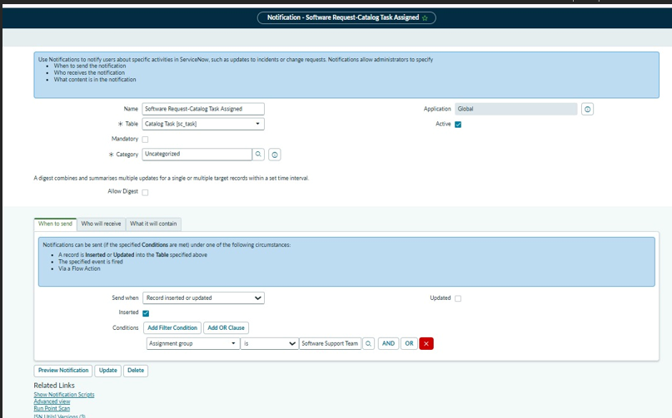

Figure 1: Licensed Software Installation Request – Configured Catalog Variables

2.3 Configure the Request Form
The Service Catalog form was designed to make the software request process simple and structured for employees.
The form captures the following major categories of information:
Software Information
- Software name
- Software version
- License type
Requester Information
- Employee name
- Manager name
- Department
Installation Information
- Target device/system
- Required installation date
Business Information
- Business justification
Priority Information
- Urgency
This information is later consumed by the workflow to determine the appropriate approval and fulfillment path.

2.4 Form Validation and Mandatory Fields
Required fields were configured to ensure that employees cannot submit an incomplete software request.

Mandatory information includes the key details required to process the request, such as:
- Software selection
- Software version
- Business justification
- Required date
- Employee name
- Installation device
- Manager
- Department
- Urgency
- License type
This validation improves data quality and prevents incomplete requests from entering the approval and fulfillment process.

2.5 Configure User-Friendly Form Behavior
The Service Catalog form was configured to provide a structured and user-friendly experience.
The form configuration supports:
- Selection of predefined software options.
- Selection of supported software versions.
- Selection of urgency.
- Selection of license type.
- Entry of business justification.
- Selection of the employee/requested-for information.
- Identification of the installation device.
- Capture of manager and department information.
- Required-date selection.
The collected information is carried forward to the Requested Item (RITM) and subsequently becomes available to the automated workflow.

2.6 Request and Requested Item Generation

When the employee submits the catalog form, ServiceNow generates the corresponding request records.
The process follows:

Employee → Service Catalog Item → Catalog Variables → Submit → Request (REQ) → Requested Item (RITM)

The RITM contains the submitted catalog variables and becomes the primary record used by the software installation workflow.
The workflow then uses this information for:

- Priority determination
- License availability checking
- Approval processing
- Software asset/license approval
- Catalog task creation
- Fulfillment
- Status updates
- Notifications
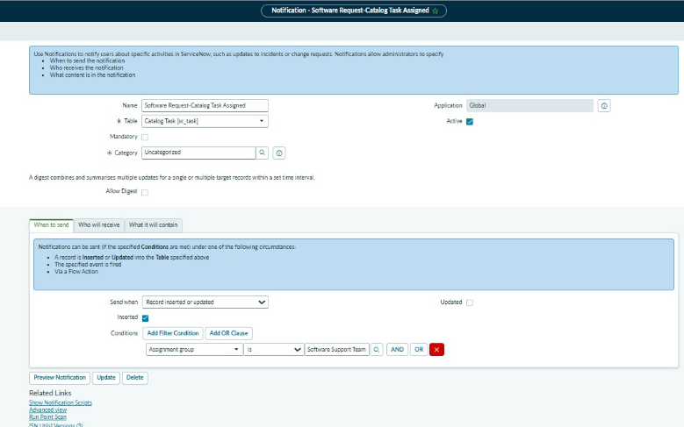
Figure 2: Generated Requested Item with Software Installation Request Details

2.7 Integration with the Workflow
The configured catalog variables are directly used by the Software Installation Workflow.
The workflow retrieves the catalog variables from the submitted request and uses them to control the subsequent processing.
The implemented process is:
Catalog Form → RITM → Get Catalog Variables → Priority Processing → License Lookup → Approval → License Decision → Software Asset Approval → Catalog Task → Fulfillment → Notification
This ensures that the information entered by the employee is not lost and is available throughout the complete request lifecycle.

2.8 Example of Configured Request
An example request was successfully created with values similar to:
- Software Version: Latest Supported Version
- Software: Adobe Acrobat
- Business Justification: For files compression
- Required Date: 2026-09-15
- Employee: David Loo
- Device: ASSET-IBM
- Manager: Bud Richman
- Department: Development
- Urgency: Medium
- License Type: LICENSED
This confirms that the Service Catalog form is successfully capturing the information required for downstream processing.
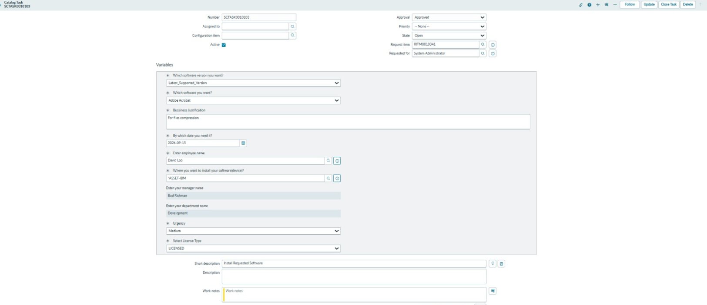
Figure 3: Example Software Installation Request with Submitted Variables
Phase 3 – UI/UX Development & Customization
The third phase focuses on improving the user interface and user experience of the Licensed Software Installation Request in ServiceNow. The objective is to make the catalog request form simple, clear, and easy for employees to complete while ensuring that the required information is captured correctly.
3.1 UI/UX Design Objectives
The following objectives were considered while customizing the request form:
- Provide a simple and user-friendly software request form.
- Use clear and meaningful field labels.
- Organize the request information logically.
- Make important fields mandatory.
- Reduce unnecessary user input.
- Provide appropriate field types such as choice fields and reference fields.
- Ensure that the form is easy for employees to understand and submit.
- Support the approval and fulfillment teams by presenting complete request information.
3.2 Form Layout and Field Organization
The Licensed Software Installation Request form is organized around the information required to process a software installation request.
Software Information
- Which software you want?
- Which software version you want?
- Select License Type
Requester Information
- Enter employee name
- Enter your manager name
- Enter your department name
Installation Information
- Where you want to install your software/device?
- By which date you need it?
Business Information
- Business Justification
Priority Information
- Urgency
This arrangement helps the requester provide information in a logical sequence.
3.3 Catalog UI Policies
Catalog UI Policies are used to control the behavior and visibility of catalog variables based on request conditions.
The UI policies help to:
- Display or hide fields when required.
- Make fields mandatory when applicable.
- Make fields read-only when necessary.
- Improve the overall form experience.
- Prevent users from entering unnecessary information.
These policies ensure that the form dynamically responds to the user's selections.
3.4 Catalog Client Scripts
Catalog Client Scripts are used to provide client-side behavior and validation on the software request form.
The customization supports:
- Validation of user-entered information.
- Automatic handling of selected values.
- Preventing incomplete or invalid submissions.
- Improving interaction between catalog variables.
- Providing a smoother request submission experience.
3.5 Mandatory Field Validation
Important fields are configured as mandatory so that the request contains sufficient information before submission.
For example, the requester must provide:
- Software
- Software version
- Business justification
- Required date
- Employee
- Device
- Manager
- Department
- Urgency
- License type
This prevents incomplete requests from entering the workflow.
3.6 User-Friendly Field Configuration
Appropriate variable types are used according to the information being captured.
For example:
Field | UI Purpose
Software | Select the required software
Software Version | Select supported version
Business Justification | Enter business requirement
Required Date | Specify installation date
Employee | Identify requester/recipient
Device | Identify target device
Manager | Identify approver
Department | Identify business unit
Urgency | Select request priority
License Type | Identify licensing category
3.7 Example of Customized Request Form
A completed request demonstrates how the customized UI captures the information required for processing.
Example values include:
- Software: Adobe Acrobat
- Software Version: Latest Supported Version
- Business Justification: For files compression
- Required Date: 2026-09-15
- Employee: David Loo
- Device: ASSET-IBM
- Manager: Bud Richman
- Department: Development
- Urgency: Medium
- License Type: LICENSED

Figure 3.1: Licensed Software Installation Request – User-Friendly Catalog Form with Configured Fields
3.8 UI/UX and Workflow Integration
The customized form is designed to work with the subsequent automation process:
User Interface → Catalog Variables → Request Submission → RITM → License Validation → Approval → Installation Task → Fulfillment
Therefore, the UI/UX configuration is not only focused on appearance but also ensures that the information collected from the employee can be consumed by the workflow.
3.9 Phase 3 Outcome
At the end of Phase 3:
- The catalog form has a clear and structured layout.
- Catalog variables are presented in a user-friendly manner.
- Mandatory-field validation is implemented.
- UI Policies and Client Scripts support dynamic form behavior.
- The form captures all information required for approval and fulfillment.
- The customized form is ready for integration with the automated workflow.

Phase 4 – Workflow Automation & Approval
The fourth phase focuses on automating the complete processing of the Licensed Software Installation Request after the employee submits the Service Catalog form. The objective is to ensure that requests are validated, license availability is checked, approvals are obtained, installation tasks are created, and users are notified automatically.
4.1 Workflow Automation Overview
The workflow is designed to reduce manual processing and ensure that every software request follows a controlled process.
Employee → Catalog Request → RITM → Validation → License Check → Approval → License Decision → Software Asset Approval → Catalog Task → Fulfillment → Notification
The workflow is implemented using the ServiceNow workflow/Flow Designer environment.
4.2 Workflow Configuration
The configured workflow is:
SIRA_Software_Installation_Workflow
The workflow processes the Requested Item (RITM) generated from the Licensed Software Installation Request catalog item.
The workflow contains activities for:
- Retrieving catalog variables
- Processing request priority
- Checking software license availability
- Requesting approval
- Processing the approval decision
- Performing software asset/license approval
- Creating the catalog task
- Assigning the task to the Software Support Team
- Completing the fulfillment process
- Sending notifications
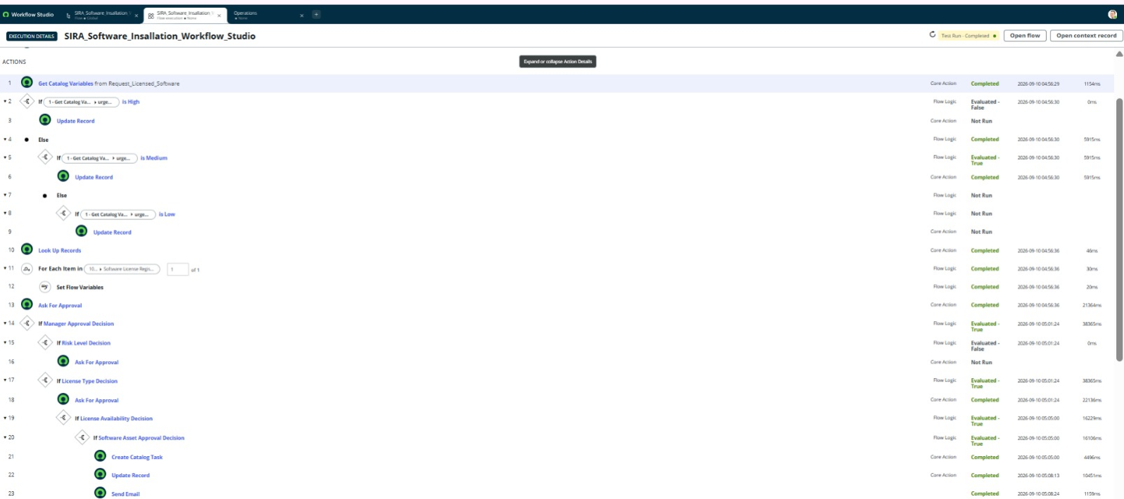
Figure 4.1: SIRA Software Installation Workflow – Workflow Automation Configuration
4.3 Get Catalog Variables
After the employee submits the request, the workflow retrieves the catalog variables from the Requested Item.
The variables include:
- Software
- Software Version
- Business Justification
- Required Date
- Employee
- Device
- Manager
- Department
- Urgency
- License Type
These values are then used by the workflow for validation, priority processing, license checking, approval, and fulfillment.
4.4 Priority Processing
The workflow processes the request based on the selected Urgency.
The priority information is used to determine the appropriate SLA and processing path.
For example:
- High urgency → High-priority SLA
- Medium urgency → Normal-priority SLA
- Low urgency → Low-priority processing
This ensures that urgent software installation requests receive appropriate attention.
4.5 License Availability Check
The workflow checks whether a valid license is available for the requested software.
The basic logic is:
Requested Software → Check License Inventory → License Available?
If the license is available, the request proceeds toward approval and fulfillment.
If the license is unavailable, the request can be routed through the appropriate decision or exception path rather than proceeding directly to installation.
4.6 Approval Process
After the initial validation and license check, the request is routed for approval.
The manager/appropriate approver reviews the request based on:
- Requested software
- Business justification
- Employee
- Department
- Device
- Required date
- Urgency
- License information
The approval decision determines whether the request can proceed.
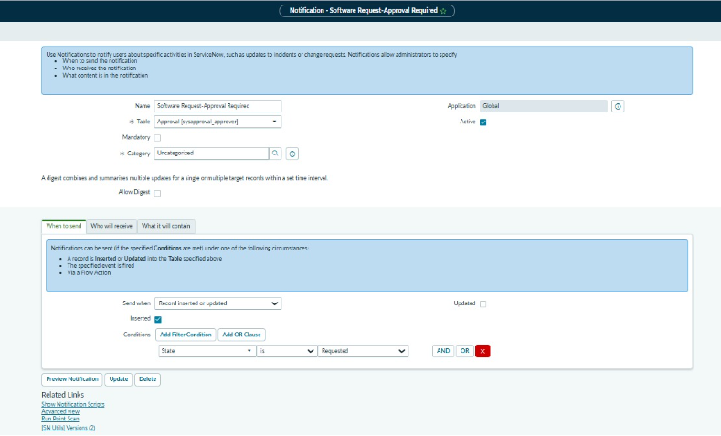
Figure 4.2: Software Request – Approval Required Notification Configuration
4.7 Approval Decision
The workflow evaluates the approval result.
If Approved
The workflow continues to the next stages:
Approval → Software Asset Approval → Catalog Task → Software Installation
If Rejected
The request does not proceed to software installation and the requester is informed about the approval decision.
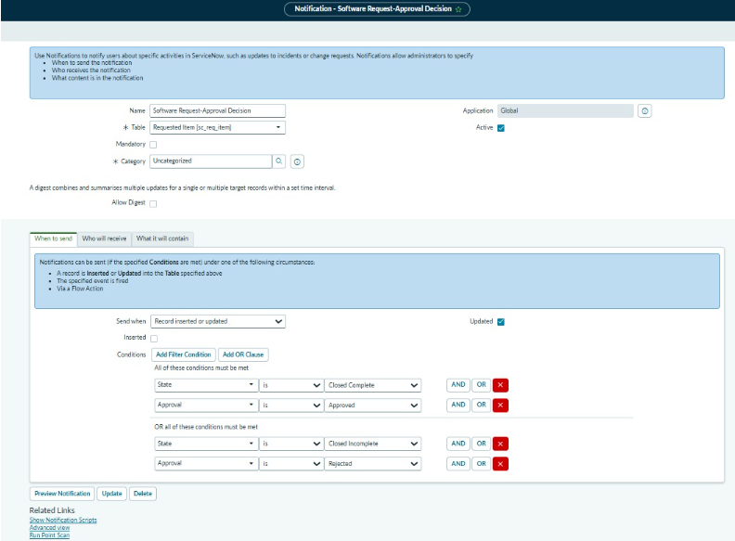
Figure 4.3: Software Request – Approval Decision Notification
4.8 Software Asset Approval
After the required request approval, the workflow performs the software asset/license approval step.
This ensures that the software installation is consistent with the organization's licensing requirements and available software inventory.
The process helps prevent unauthorized or unlicensed software installations.
4.9 Catalog Task Creation
Once the request passes the required approval and license checks, the workflow creates a Catalog Task (sc_task) for the software support team.
The task contains the information required to perform the installation.
The task is assigned to:
Software Support Team
The support team can then process the installation and update the task status.
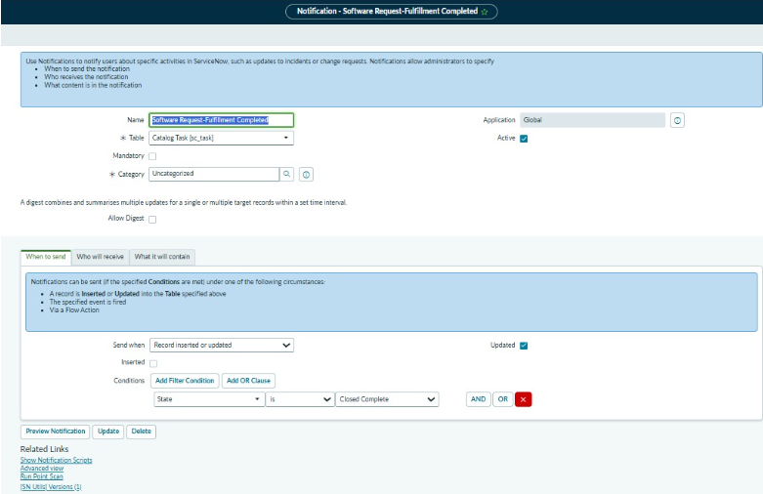
Figure 4.4: Software Request – Catalog Task Assigned Notification Configuration
4.10 Fulfillment Process
The fulfillment process follows:
Approved Request → Catalog Task → Software Support Team → Software Installation → Task Completion
The support team installs the requested software on the specified device and updates the catalog task.
Once fulfillment is completed, the request can move toward closure.
4.11 Notifications
Automated notifications keep the requester and support teams informed throughout the process.
The configured notifications include:
- Software Request – Approval Required
- Approval Record Assigned – Request
- Software Request – Approval Decision
- Software Request – Catalog Task Assigned
- Software Request – Fulfillment Completed
These notifications provide visibility into important request events.
4.12 SLA and Priority Automation
SLAs are configured to monitor request processing time.
Examples include:
SLA | Target
Software_Request_High_Priority | 1 Day
Software_Request_Normal_Priority | 2 Days
The SLA conditions are associated with the request state and urgency so that the system can monitor whether requests are completed within the expected time.
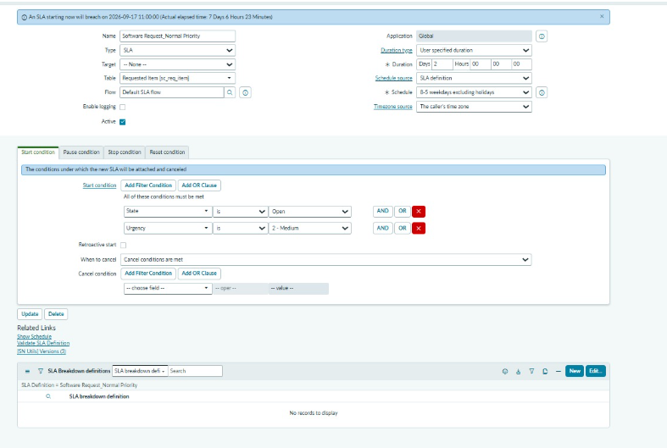
Figure 4.5: Software Request SLA Configuration – High Priority
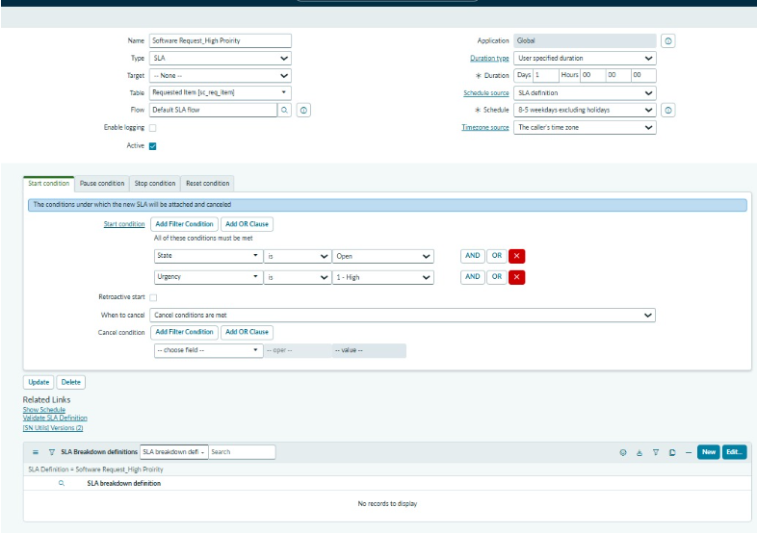
Figure 4.6: Software Request SLA Configuration – Normal Priority
4.13 Update Set
The workflow automation configuration is captured in the update set:
SIRA_Workflow_Automation
This allows the workflow-related configuration to be tracked and moved between ServiceNow instances as required.
4.14 End-to-End Workflow
The complete automated process is:
Employee
↓
Licensed Software Installation Request
↓
Request (REQ) / Requested Item (RITM)
↓
Get Catalog Variables
↓
Priority Processing
↓
License Lookup
↓
Manager Approval
↓
License/Asset Approval
↓
Catalog Task Creation
↓
Software Support Team
↓
Software Installation
↓
Fulfillment Completed
↓
Requester Notification
↓
Request Closure
4.15 Phase 4 Outcome
At the end of Phase 4:
- The software request workflow is automated.
- Catalog variables are retrieved automatically.
- Request priority is processed.
- License availability is checked.
- Approval is automated.
- Approval decisions control the next workflow step.
- Catalog tasks are automatically created.
- Tasks are assigned to the Software Support Team.
- SLAs monitor request processing time.
- Notifications keep users informed.
- The complete request lifecycle is traceable.

Phase 5 – Testing & Security
The fifth phase focuses on validating the Licensed Software Installation Request to ensure that the configured catalog form, workflow, approvals, notifications, SLAs, and security controls work correctly. Testing is performed from the employee, approver, and IT support perspectives.
5.1 Testing Objectives
The main objectives of this phase are:
- Verify that the catalog request form works correctly.
- Confirm that mandatory fields and validations work as expected.
- Verify REQ and RITM creation.
- Validate license availability processing.
- Verify approval routing and approval decisions.
- Confirm automatic Catalog Task creation.
- Verify assignment to the Software Support Team.
- Validate SLA behavior based on urgency.
- Verify all configured notifications.
- Confirm request status updates and closure.
- Ensure appropriate access and security controls are applied.
5.2 Functional Testing
Functional testing verifies that each major function of the software request process operates according to the requirements.
Test Area | Expected Result
Catalog item access | Employee can access the software request
Mandatory fields | Request cannot be submitted with required data missing
Software selection | Selected software is captured correctly
Request submission | REQ and RITM are created
License validation | License availability is checked
Approval | Request is routed to the appropriate approver
Approval decision | Approved/rejected paths work correctly
Catalog Task | Task is created after required approval
Assignment | Task is assigned to Software Support Team
Fulfillment | Installation task can be completed
Notification | Relevant users receive notifications
Closure | Completed request reaches the appropriate final state
5.3 Catalog Form Testing
The catalog form is tested with valid and invalid inputs.
Valid Input Testing
A complete request is submitted with all required values, such as:
- Software: Adobe Acrobat
- Software Version: Latest Supported Version
- Business Justification: For files compression
- Required Date: 2026-09-15
- Employee: David Loo
- Device: ASSET-IBM
- Manager: Bud Richman
- Department: Development
- Urgency: Medium
- License Type: LICENSED
The system should successfully submit the request and create the corresponding RITM.
Invalid Input Testing
The form is also tested by:
- Leaving mandatory fields empty.
- Entering incomplete information.
- Selecting invalid or unsupported values.
- Attempting to submit without required request details.
The system should prevent incomplete requests from being submitted.
5.4 Workflow Testing
The complete workflow is tested from submission through fulfillment.
Employee Submission → RITM → License Check → Approval → Asset Approval → Catalog Task → Fulfillment → Notification → Closure
Each workflow stage is verified to ensure that the request moves to the correct next step.
5.5 Approval Testing
Approval testing verifies both possible approval outcomes.
Approved Request
Request → Approval → Approved → Catalog Task → Software Installation
The approved request should continue toward fulfillment.
Rejected Request
Request → Approval → Rejected → Requester Notification
A rejected request should not proceed to software installation.
5.6 Notification Testing
The following notifications are tested:
- Software Request – Approval Required
- Approval Record Assigned – Request
- Software Request – Approval Decision
- Software Request – Catalog Task Assigned
- Software Request – Fulfillment Completed
The notification configuration and delivery are verified to ensure that the correct recipient receives the appropriate message at the correct stage.
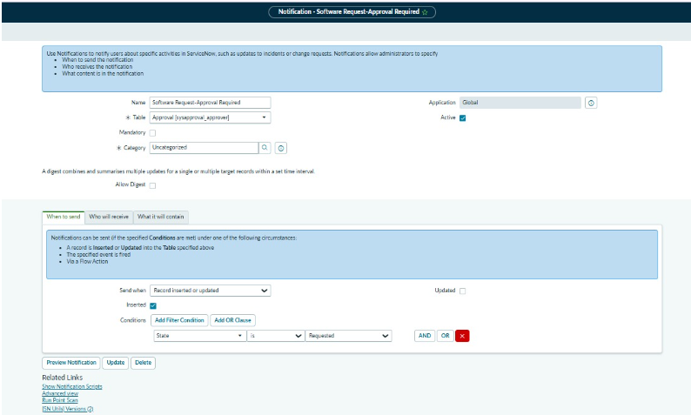
Figure 5.1: Software Request – Approval Required Notification
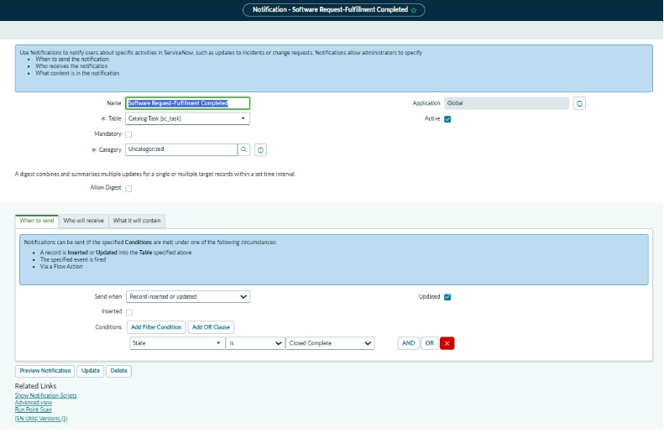
Figure 5.2: Software Request – Catalog Task Assigned Notification
5.7 Email Validation
Email records are reviewed to verify that notifications were generated successfully.
Testing includes:
- Notification name
- Recipient
- Subject
- Message content
- Trigger condition
- Date/time generated
- Request/RITM reference

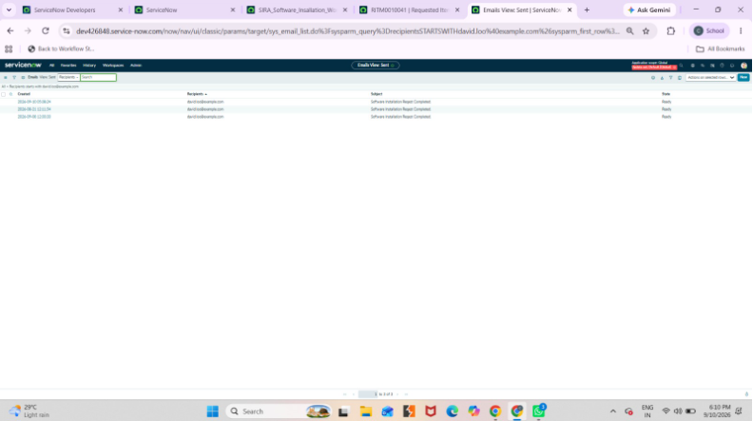
Figure 5.3: Software Request Notification – Sent Email Record
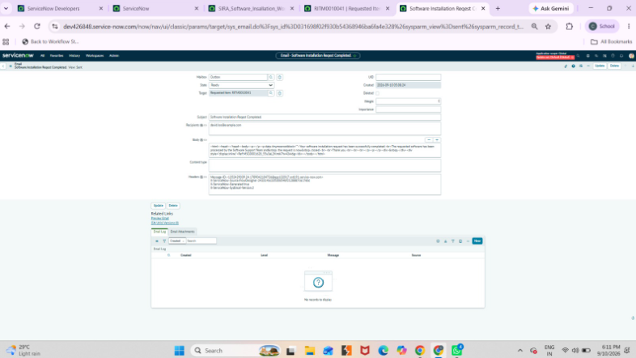
Figure 5.4: Software Request Notification – Email Preview

5.8 SLA Testing
SLA testing verifies that the request receives the appropriate SLA based on urgency.
Configured examples include:
Priority | SLA Target
High | 1 Day
Medium | 2 Days
Low | Based on configured low-priority SLA
The SLA should start when its defined conditions are satisfied and should monitor the request until completion or the applicable stop condition.
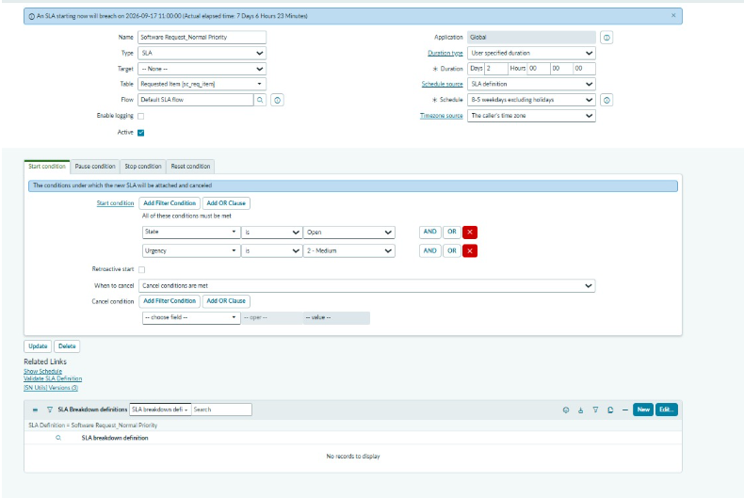
Figure 5.5: Software Request – High Priority SLA Configuration
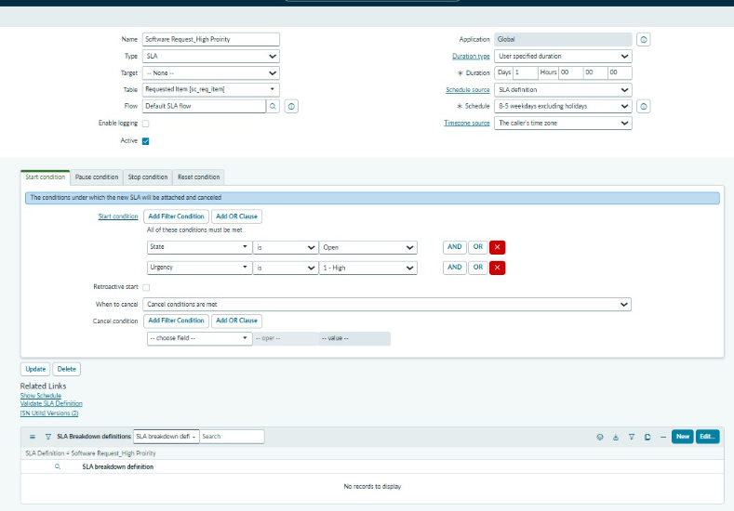
Figure 5.6: Software Request – Normal Priority SLA Configuration
5.9 Security Testing
Security testing ensures that only authorized users can access or modify appropriate information.
The following areas are considered:
- User roles
- Catalog item access
- Requester access
- Approver access
- IT support access
- ACL restrictions
- Catalog Task access
- Sensitive request information
- Unauthorized modification prevention
The objective is to ensure that employees can submit requests while administrative and fulfillment functions remain restricted to authorized personnel.
5.10 Role and Access Validation
Access is tested from different user perspectives.
User | Expected Access
Employee | Submit and view own software request
Manager/Approver | Review and approve assigned requests
Software Support Team | Access and process assigned Catalog Tasks
ServiceNow Administrator | Configure and administer the complete process
This ensures separation of responsibilities between requesters, approvers, support teams, and administrators.
5.11 End-to-End Testing
The complete scenario is tested using a real software installation request.
Employee submits request
↓
REQ/RITM created
↓
License availability checked
↓
Manager approval requested
↓
Approval decision recorded
↓
Catalog Task created
↓
Software Support Team assigned
↓
Software installed
↓
Fulfillment completed
↓
Requester notified
↓
Request closed
Successful completion of this scenario confirms that the major components work together correctly.
5.12 Testing Results
The testing phase confirms that:
- The catalog form accepts valid requests.
- Mandatory fields are enforced.
- REQ/RITM records are generated correctly.
- Workflow activities execute in the expected sequence.
- Approval routing works correctly.
- License validation is incorporated into the process.
- Catalog Tasks are created and assigned correctly.
- Notifications are generated.
- SLAs are applied according to priority.
- Security and access controls restrict unauthorized actions.

Phase 6 – Deployment, Documentation & Final Presentation
The sixth and final phase focuses on preparing the Licensed Software Installation Request application for deployment, documenting the completed implementation, and presenting the final solution. This phase ensures that the configured ServiceNow components are properly packaged, validated, and ready for demonstration or transfer to another environment.
6.1 Deployment Preparation
Before deployment, the completed configuration is reviewed to ensure that all required components are included.
The deployment package includes:
- Service Catalog Item
- Catalog Variables
- Catalog UI Policies
- Catalog Client Scripts
- Workflow / Flow Designer configuration
- Approval configuration
- License validation logic
- Catalog Tasks
- Notifications
- SLAs
- Security and access configuration
- Dashboard configuration
6.2 Update Set Configuration
The project configuration is captured using the ServiceNow Update Set:
SIRA_Workflow_Automation
The update set provides a controlled method for tracking configuration changes and moving the developed solution between ServiceNow instances.
The update set contains the required customer updates associated with the workflow automation and related configuration.

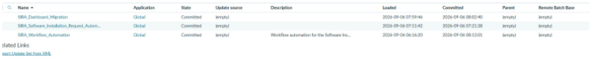
Figure 6.1: SIRA_Workflow_Automation – Update Set Configuration
6.3 Review of Update Set Customer Updates
The Customer Updates section is reviewed to verify that the required configuration changes have been captured.
The review helps confirm that important components such as workflow, notifications, scripts, and other configuration records are included before deployment.
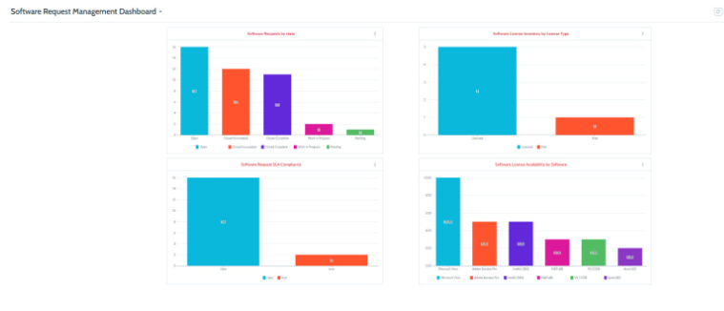
Figure 6.2: SIRA_Workflow_Automation – Captured Customer Updates
6.4 Update Set Completion and Retrieval
After development and testing are completed, the update set is prepared for deployment.
The deployment process includes:
Development → Testing → Update Set Completion → Export/Retrieve → Target Instance → Validation
The retrieved update set is reviewed before committing the changes to the target environment.
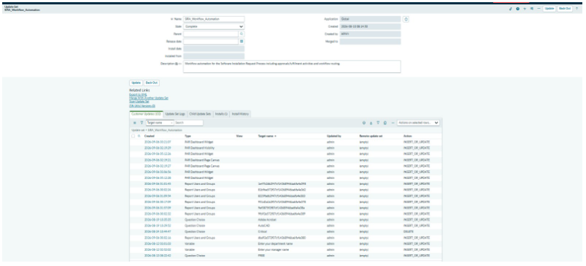
Figure 6.3: SIRA_Workflow_Automation – Retrieved/Committed Update Set

6.5 Post-Deployment Validation
After deployment, the application is validated to ensure that the configuration continues to work correctly.
The following are checked:
- Catalog item availability
- Catalog variables
- Request submission
- REQ/RITM generation
- Workflow execution
- Approval routing
- License validation
- Catalog Task creation
- Assignment to Software Support Team
- Notifications
- SLA processing
- Request completion
This ensures that deployment has not affected the functionality tested during Phase 5.
6.6 Software Request Management Dashboard
A ServiceNow dashboard is configured to provide visibility into software requests and license information.
The dashboard is:
Software Request Management Dashboard
The dashboard provides useful operational information through visual reports and metrics.
The configured dashboard metrics include:
- Software Requests by State
- Software License Inventory by License Type
- Software Request SLA Compliance
- Software License Availability by Software
These reports help administrators and support teams monitor request processing, SLA performance, and license availability.
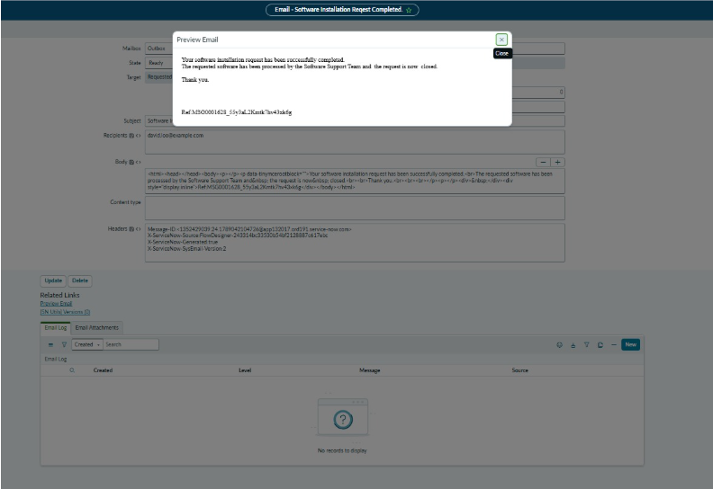
Figure 6.4: Software Request Management Dashboard
6.7 Documentation
The project documentation records the complete implementation process, including:
Phase 1 – Requirement Analysis & Planning
Requirement identification, stakeholders, functional requirements, and project planning.
Phase 2 – Service Catalog & Form Configuration
Catalog item, variables, form configuration, validation, and REQ/RITM generation.
Phase 3 – UI/UX Development & Customization
Form layout, UI Policies, Client Scripts, mandatory fields, and user experience improvements.
Phase 4 – Workflow Automation & Approval
Workflow, license validation, approval process, catalog task creation, notifications, and SLAs.
Phase 5 – Testing & Security
Functional testing, workflow testing, approval testing, notification testing, SLA testing, security testing, and end-to-end validation.
Phase 6 – Deployment, Documentation & Final Presentation
Update Set, deployment, dashboard, final validation, documentation, and project presentation.
6.8 Final Demonstration Flow
The final presentation demonstrates the complete employee software request lifecycle:
Employee
↓
Service Catalog
↓
Licensed Software Installation Request
↓
REQ / RITM Creation
↓
License Validation
↓
Manager Approval
↓
Software Asset Approval
↓
Catalog Task
↓
Software Support Team
↓
Software Installation
↓
Fulfillment Completed
↓
Requester Notification
↓
Dashboard / Reporting
↓
Request Closure
6.9 Final Project Deliverables
The completed project provides:
- Configured Licensed Software Installation Request catalog item.
- Configured catalog variables and form validation.
- Customized UI/UX.
- Automated software installation workflow.
- License availability validation.
- Approval mechanism.
- Automated Catalog Task creation.
- Software Support Team assignment.
- SLA configuration.
- Automated notifications.
- Security and role-based access.
- Software Request Management Dashboard.
- Update Set for deployment.
- Complete project documentation.
- Final project demonstration.
6.10 Phase 6 Outcome
At the end of Phase 6, the Licensed Software Installation Request solution is fully documented, tested, packaged using the appropriate Update Set, and prepared for deployment and final presentation.
The final solution provides an end-to-end automated process for requesting, approving, validating, installing, tracking, and completing licensed software requests in ServiceNow.

Final Workflow – Image Evidence Set
The following screenshots provide visual evidence for the complete process, from catalog request and workflow automation through approval, fulfillment, SLA monitoring, dashboard reporting, and deployment.

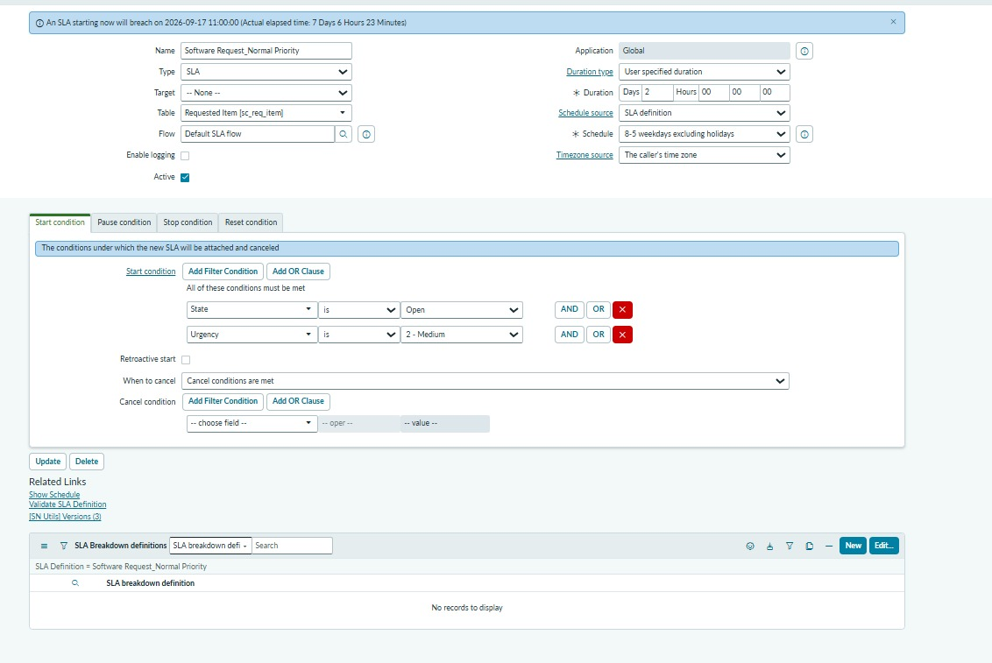
Figure 1: Licensed Software Installation Request – Submitted Request / Configured Variables
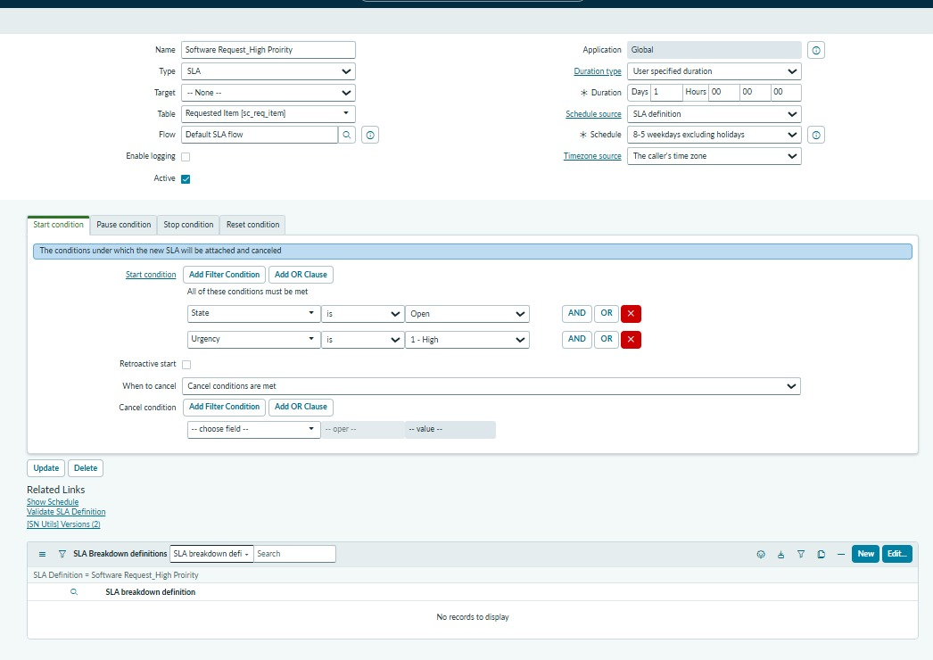
Figure 2: Licensed Software Installation Request – Catalog Form Evidence

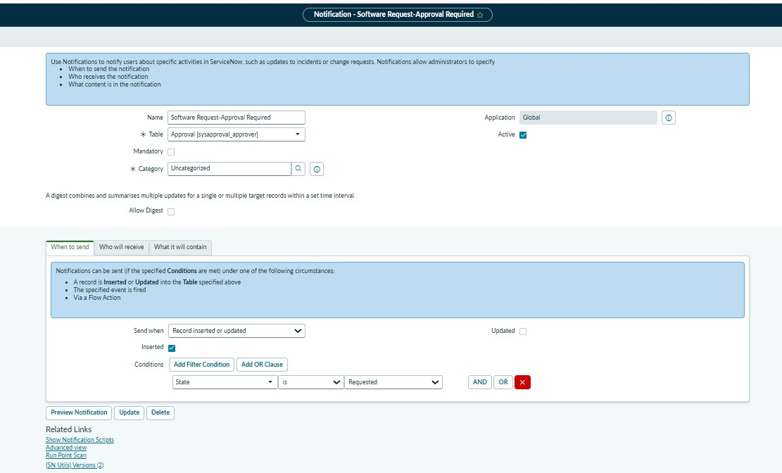
Figure 3: SIRA Software Installation Workflow – Workflow Automation Configuration
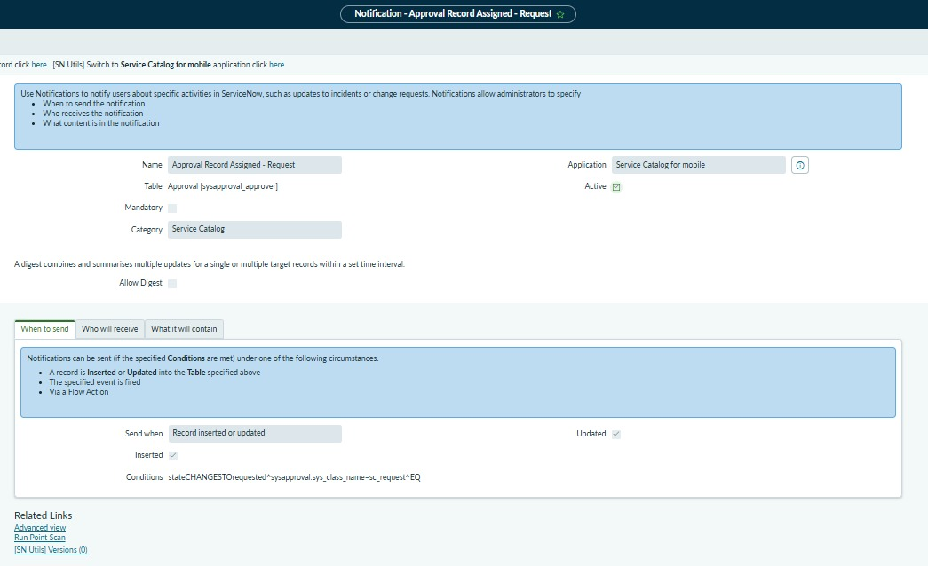
Figure 4: Software Request – Approval Required Notification Configuration

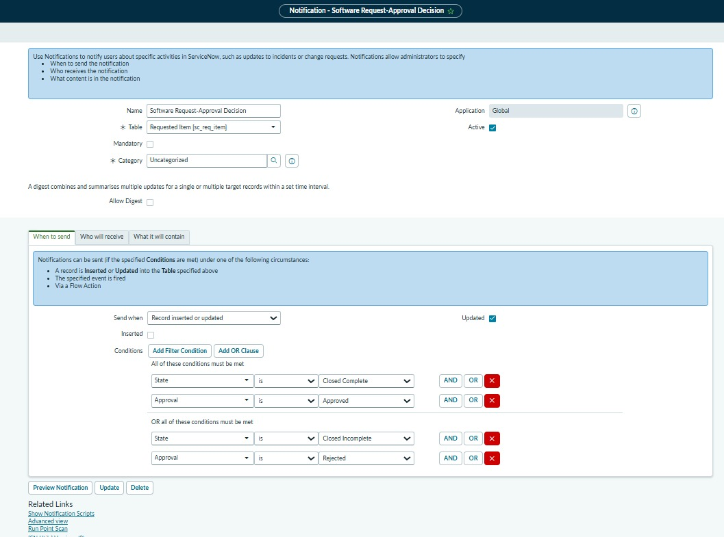
Figure 5: Approval Record Assigned – Request Notification
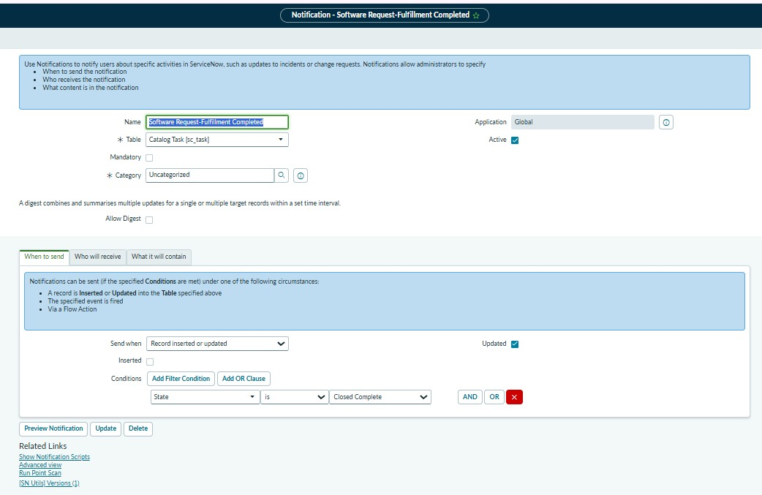
Figure 6: Software Request – Approval Decision Notification

Figure 7: Software Request – Catalog Task Assigned Notification Configuration
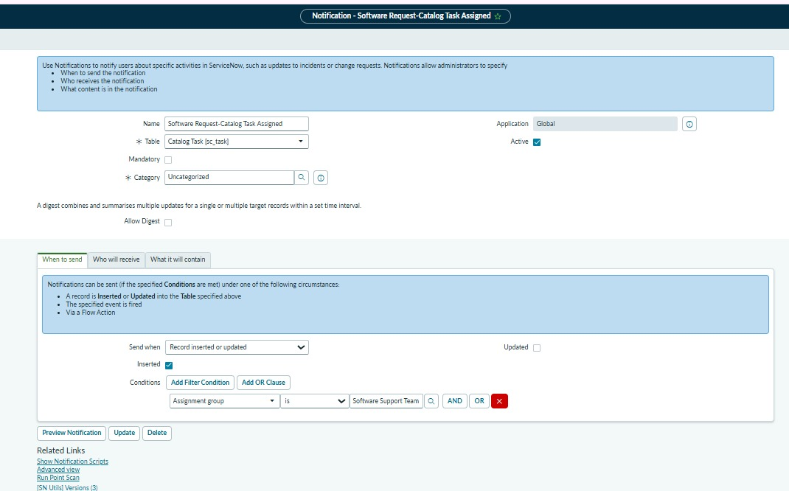
Figure 8: Software Request – Fulfillment Completed Notification
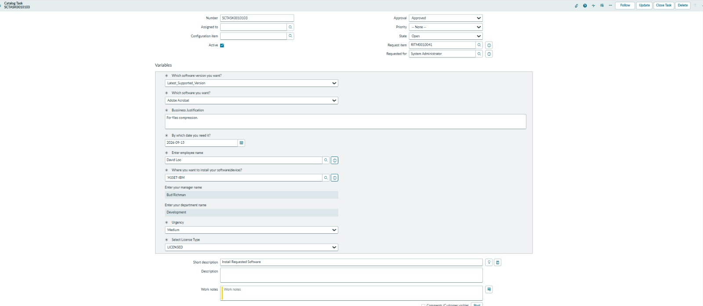
Figure 9: Software Request – Sent Email Evidence
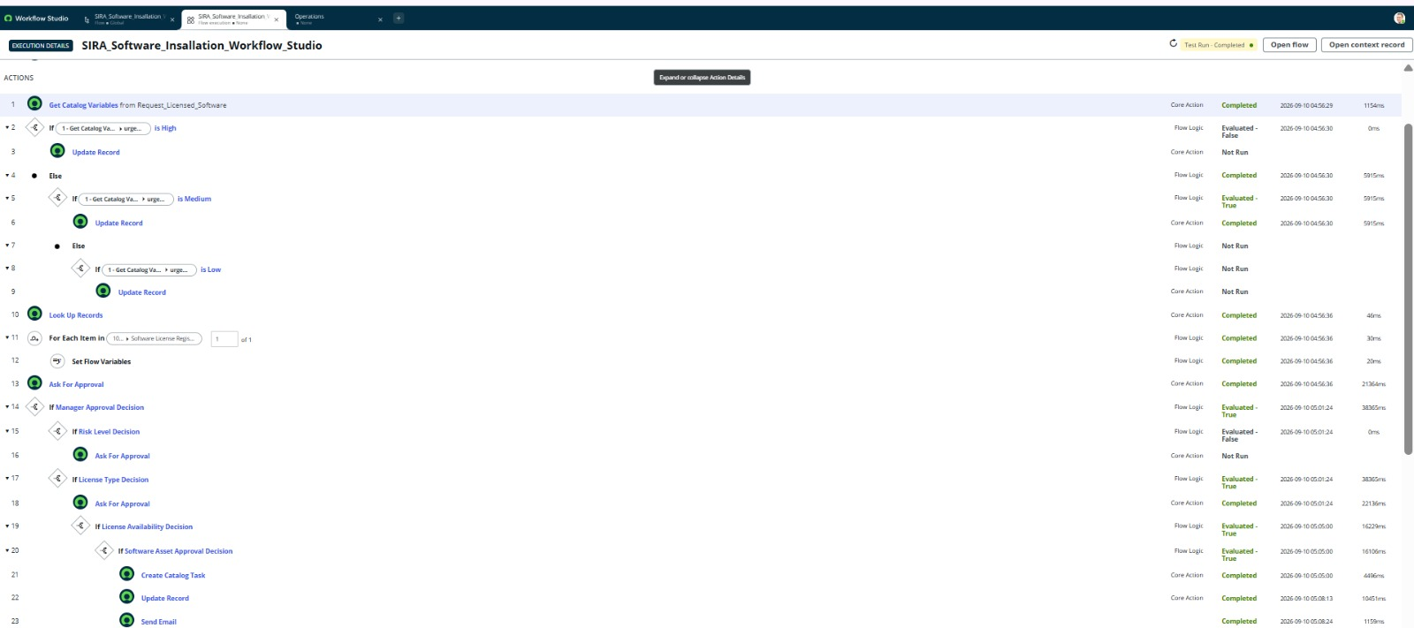
Figure 10: Software Request – Email Record / Details
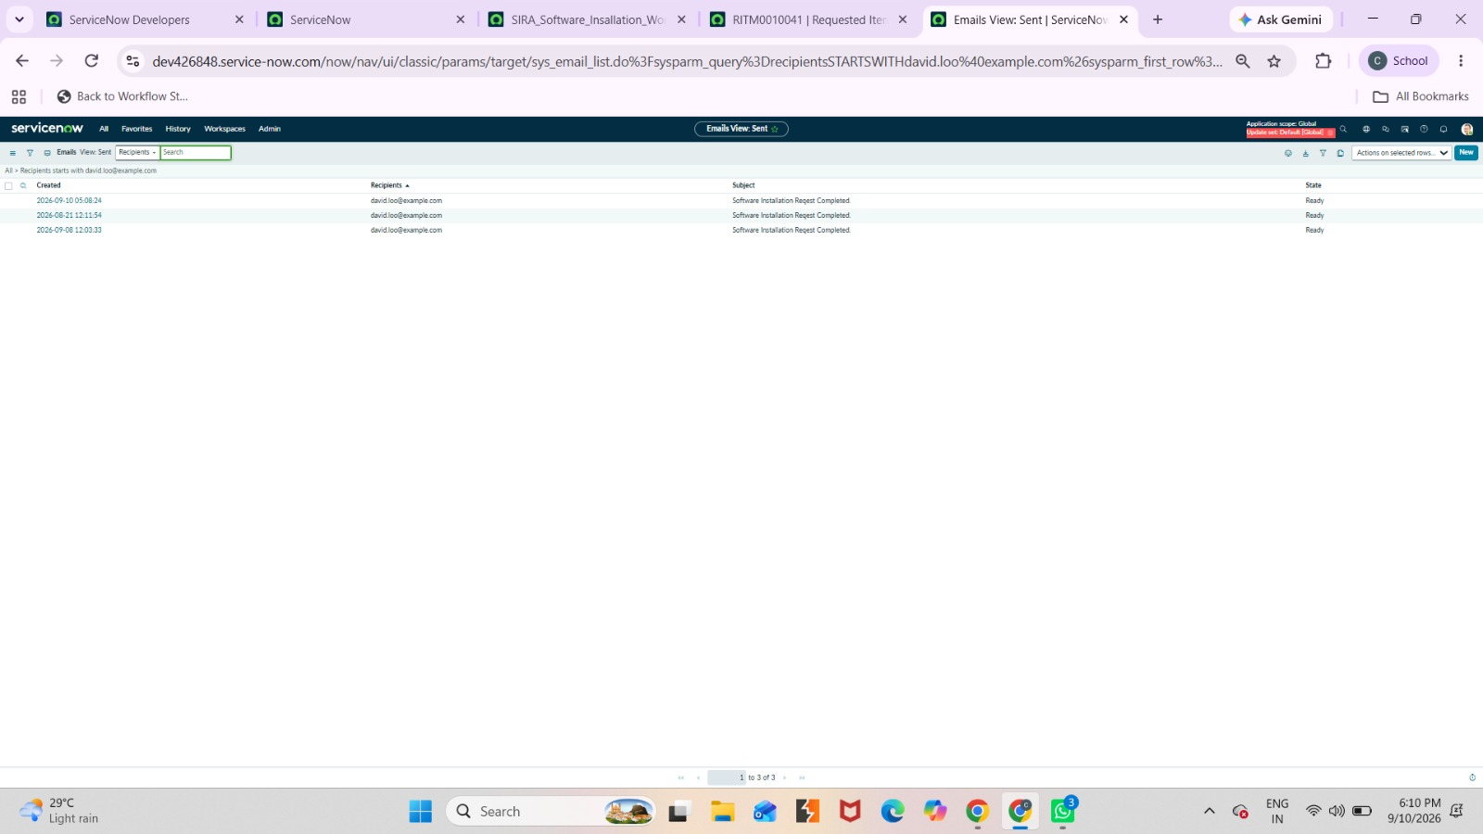
Figure 11: Software Request – Email Preview

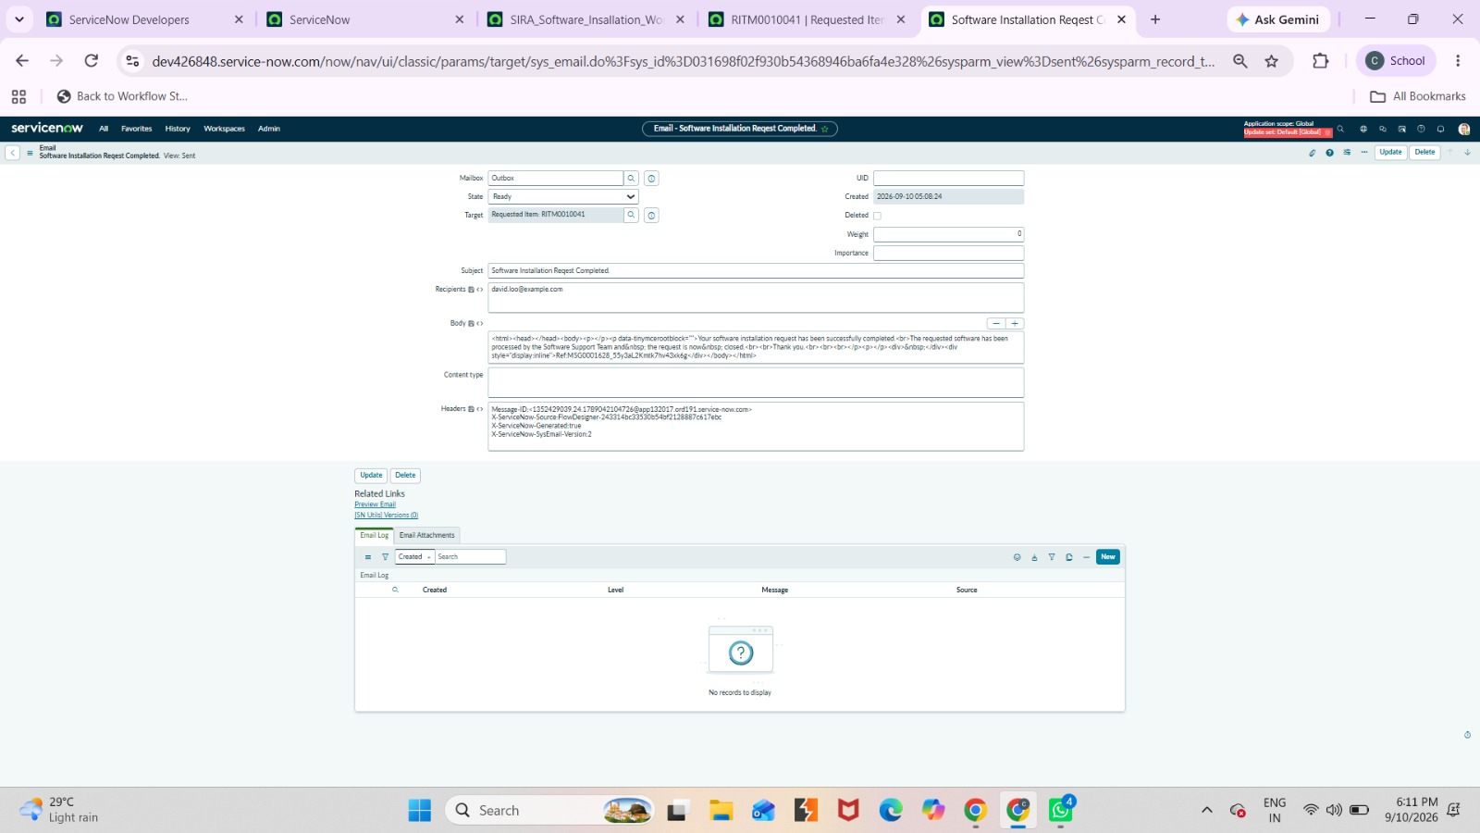
Figure 12: Software Request – High Priority SLA Configuration
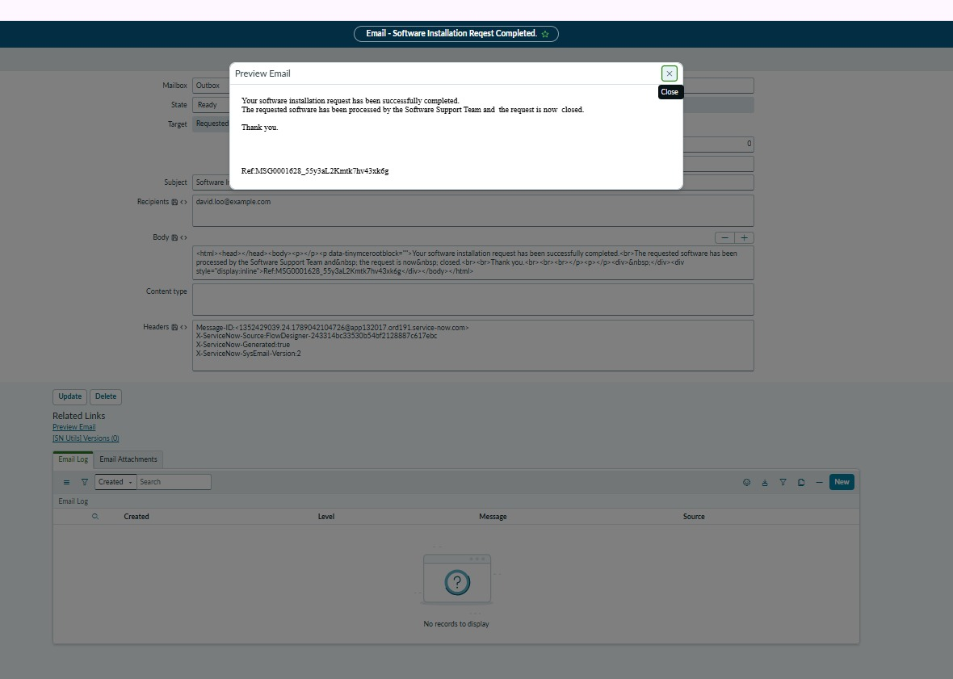
Figure 13: Software Request – Normal Priority SLA Configuration
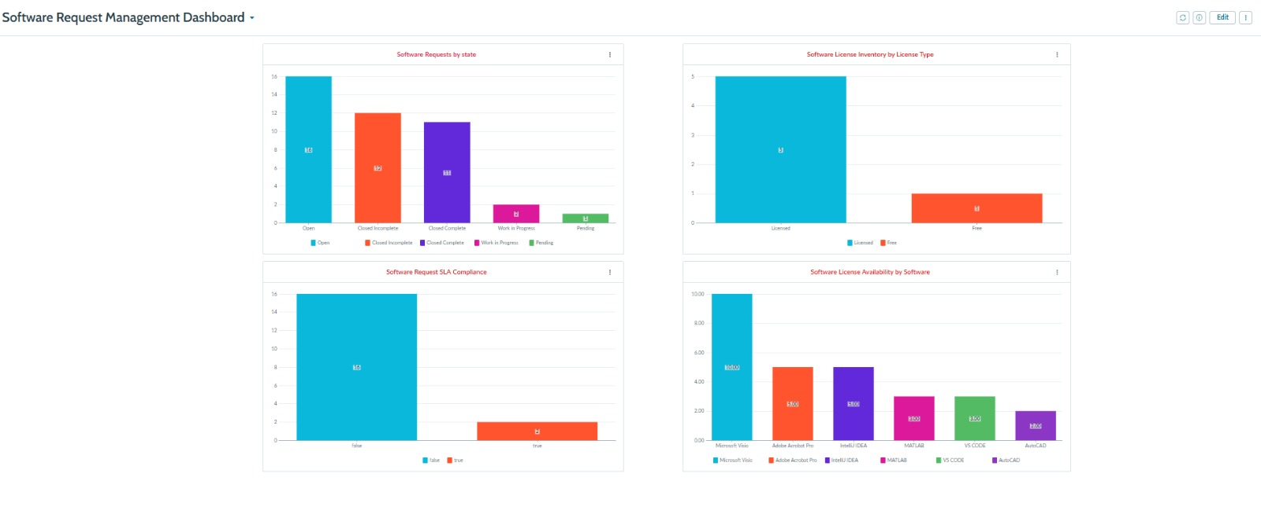
Figure 14: Software Request Management Dashboard
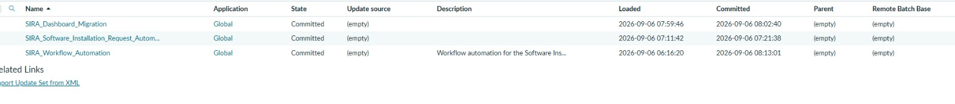
Figure 15: SIRA_Workflow_Automation – Update Set
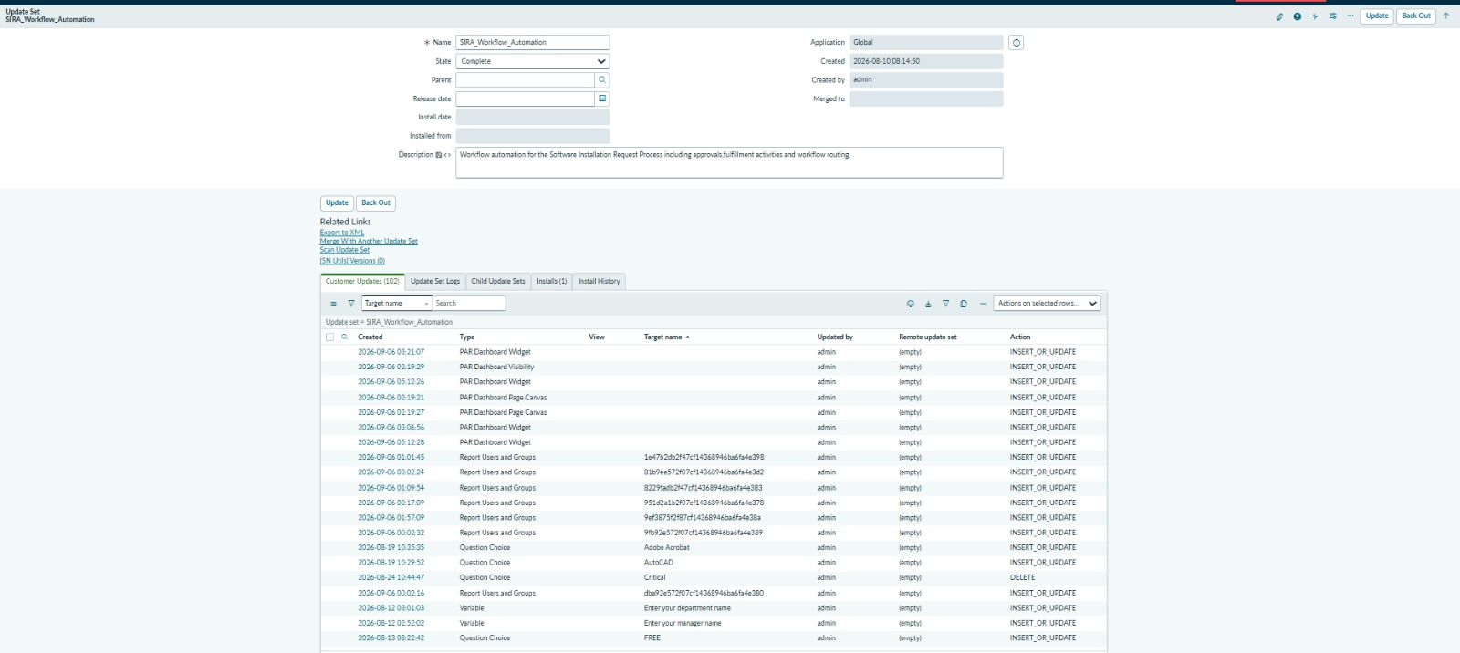
Figure 16: SIRA_Workflow_Automation – Customer Updates
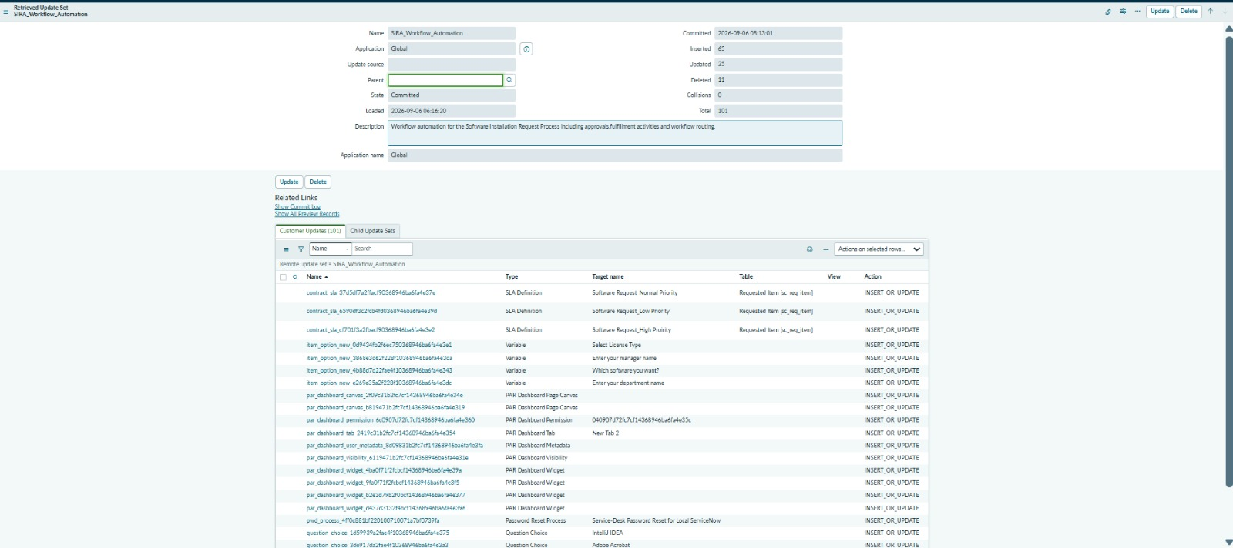
Figure 17: SIRA_Workflow_Automation – Retrieved / Committed Update Set

Project Conclusion
The Licensed Software Installation Request through the Service Catalog project successfully provides an automated and controlled process for managing employee software installation requests in ServiceNow.
The solution begins with the employee submitting a request through the Service Catalog, where the required software, version, business justification, employee, device, manager, department, urgency, and license information are captured. The request is then processed through an automated workflow that performs license validation, priority processing, approval, software asset validation, and Catalog Task creation.
The implementation also includes SLA management, automated notifications, role-based security, fulfillment tracking, dashboard reporting, and Update Set deployment. This reduces manual effort, improves request visibility, ensures proper approval before software installation, and supports better control over licensed software usage.
Overall, the project demonstrates how ServiceNow can be used to create a standardized, traceable, secure, and efficient end-to-end software installation process. The completed solution improves the experience for employees while helping IT and software support teams manage licensed software requests effectively.
Final Project Flow
Employee Request → Service Catalog → REQ/RITM → License Validation → Approval → Software Asset Approval → Catalog Task → Software Installation → Fulfillment → Notification → Dashboard → Closure

